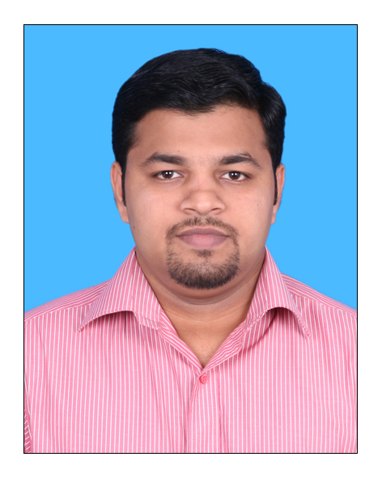
RINUSHAD ALEEL RAHMAN

#26/27, 1st Main,
7th Cross, Dattareya Nagar
Banashankari 3rd Stage
Hoskerehalli, Bangalore-85
Karnataka, India
Mobile: +91-98450-08627
Email: rinushad.aleelrahman@gmail.com
Online Portfolio: http://rinushadaleelrahman.wix.com/rinu

Objective

Aim to be associated with an esteemed organization that gives a scope to exploit my knowledge and skills in accordance with the latest development and to be a part of team and work dynamically towards the growth and grow along with the organization. Willing to work as a Team Facilitator in a challenging and creative environment.

Profile

- Over 6 Years of Experience Spread Across Designing Ads.
- Working in Hibu India Pvt Ltd. as a Team Leader

Educational Qualification

- Bachelor of Computer Application, from Bharathiar University (2003-2006)
- Master of Computer Application Distance Education
from Madurai Kamraj University (2009-2011)

Personal Skills

- Hands on experience in good Designing of ads, experience in Proof Reading and currently facilitating the team in achieving the goals of organization.
- Expertise in implementing new ideas for designing ads in an impressive and creative ways.
- Adapt and identify business requirements and implement the systems thereby, facilitating a smooth workflow.
- Effective communicator with exceptional relationship management skills with an ability to relate to people at any level of business.

Work Experience

- September 2006 – April 2012: Hibu India Pvt Ltd., Bangalore as a Sr. Graphic Designer
- April 2012 – Till date: Working as a Team Leader towards the growth of the organization.

Responsibilities of Graphic Designer:
- Design and execute the ad listings to be placed in the business directories as per the customer requirements
- Work extensively with the entire team to freeze on the page designs and layouts.
- Good understanding of the services and their complexities in the regional markets.
- Apt to present skills and maintaining work status reports for effective management information systems.

Responsibilities of Team Leader:
- Monitor daily production and quality of the team as a whole & of every
individual team member.
- Deal with any clarifications with respect to advert content and any other
Production related problems.
- Liaise between the individual team members and the Production managers.
- Ensure that the team members meet the individual and team target every day.
- Prepare and generate reports like:
a. Daily team production & quality report of the previous day for the Production Manager review
b. Send daily Absentees report to Production manager and HR Dept.
c. Send Weekly Incentive reports of individual team members to the
Production manager
d. Maintaining all the reports based on their Production, Quality,
Trainings & Incentives
- Motivate, encourage & inspire the team to achieve their targets and constantly improve on the quality.
- Assess and assist the production managers in appraising their respective team members in the Performance Appraisal Process.
- Ensure that all the team members are aware and adhere to the policies &
procedures of the company.
- Support HR & Personnel Dept. in monitoring and regulating leave taking & late coming among the team members.
- Undertake and execute any other special projects or assignments periodically assigned by the Production Managers.
- Provide training to the new entrants as and when designated to do so by the
production managers.
- Manage a Team of 12-20 members with respect to Production processes and
supporting issues.

Computer Skills

Ms-Office, Windows,
Adobe Package : Photoshop, Illustrator, Dream Weaver, Flash

Personal Details

Father’s Name | : S. Aleel Rahman
Date of Birth | : 24-03-1986
Languages Known | : English, Malayalam, Tamil, Hindi & Kannada.
Hobbies | : Listening To Music, Traveling And Photography

Declaration

I here by declare and state that the above stated and mentioned information is true and correct to the best of my knowledge

Place: Bangalore Rinushad Aleel Rahman

